Hw2 Image Sharpening

資工四 陳昱瑋 409410118

Date due: 2024/4/29

Date handed in: 2024/5/4

**Technical description**

* **Foundation of Sharpening Filters**

Sharpening filters可以透過一次微分(First Derivative)與二次微分(Second Derivative)實現。也就是透過spatial differentiation，增加邊緣的銳利度，減少低gray-level變化的權重。

1. First Derivative

Nonzero會出現在梯度變化為非0的ramp，因此對於gray-level變化會有較敏感的反應。也就是在gray-level變化快速時，對gray-level做first derivative之曲線會有大幅度的變化。

1. Second Derivative

若gray-level在某一區之變化與另一區之變化很大，則為Nonzero的ramp。有就是對於灰階變化大的區域：畫面的細節部分，回有較敏感的反應。原本已經很清楚的細節不會再做其他工作，針對黑暗中或是高光中的細節進行加強。

* **Laplacian Operator**

進行Second Derivative，進行細節的加強：

* Filter mask:
* Image enhancement by Laplacian Operator
* **Unsharp Masking and High-Boost Filtering**

假設 為input image經過模糊處理後的影像，則：

為sharpened image。

* Image enhancement by High-boost filtering

可以透過second derivative達成：

**Execution process**

* **functions**

1. Laplacian(img)

* 進行Laplacian operator
* img: input image

1. Laplacian_with_hb(img)

* 進行High-Boost，並透過Second derivative取得模糊化的image
* img: input image

1. plot(img, masked, filtered, title)

* 呈現original image, masked image, filtered image
* image: original image
* masked: masked image
* filtered: filtered image
* **Laplacian operator process**

Import image to Laplacian operator => Do Laplacian operator(with the filter ) to get masked image => Do image enhancement by the masked image

* **High-Boost process**

Import image to High-Boost process => Suppose the blurred image can obtain by the second derivative, get the sharpened image with Laplacian operator => Multiply constant “A” to the original image numpy array => Do image enhancement

* **Execution**
* Laplacian operator

python Laplacian.py

(You can modify the mask_type as you want)

* High-Boost process

python High-Booost.py

(You can modify the A as you want)

**Experimental result**

1. **Laplacian Operator**

* blurry moon processed by Laplacian operator.

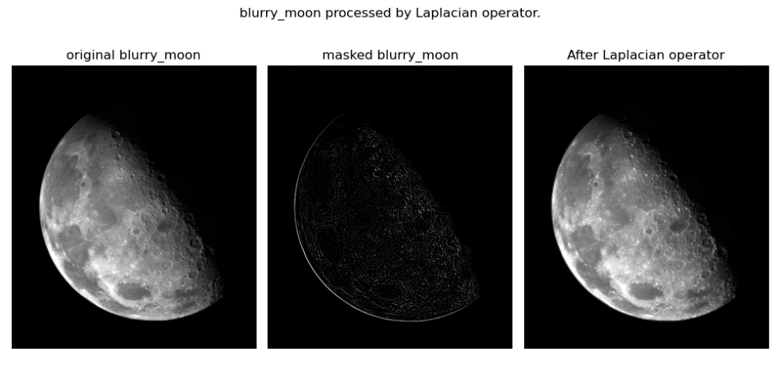

* skeleton processed by Laplacian operator.

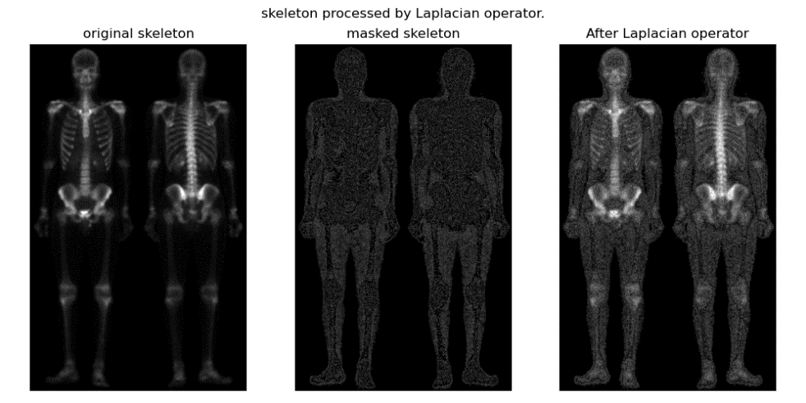

1. **Unsharp Masking and High-Boost Filter**

* blurry moon processed by High-Boost with A=1.

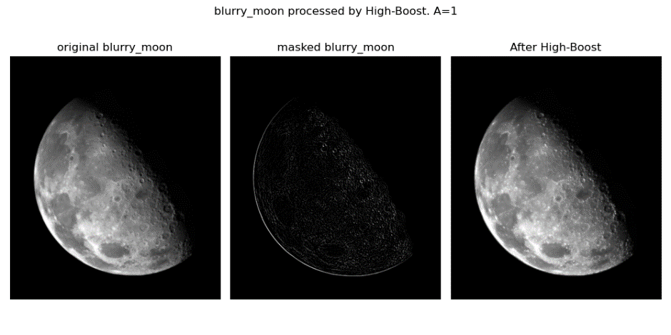

* blurry moon processed by High-Boost with A=1.5.

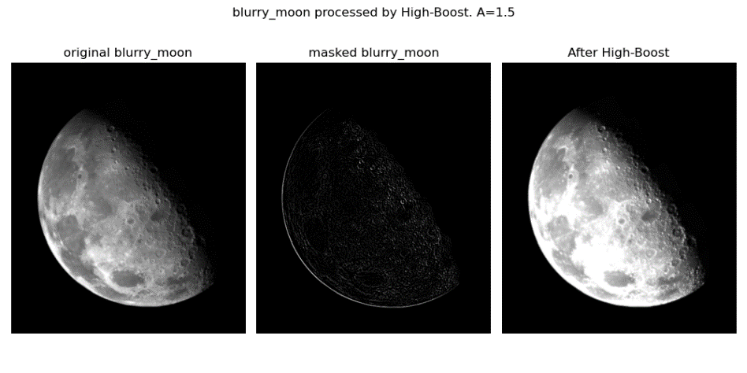

* skeleton processed by High-Boost with A=1.

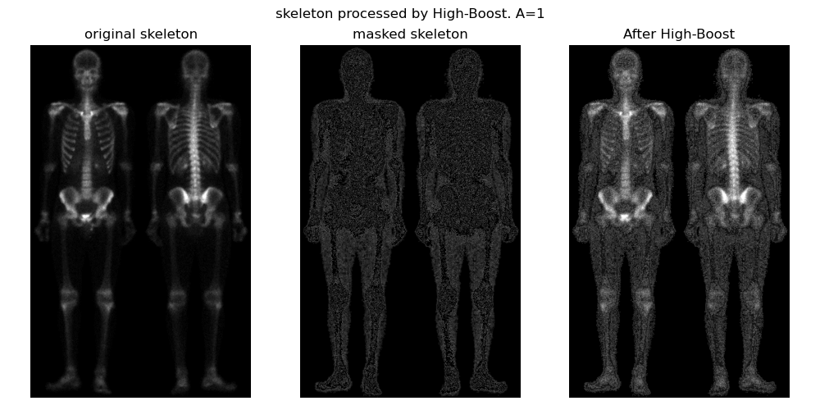

* skeleton processed by High-Boost with A=1.5.

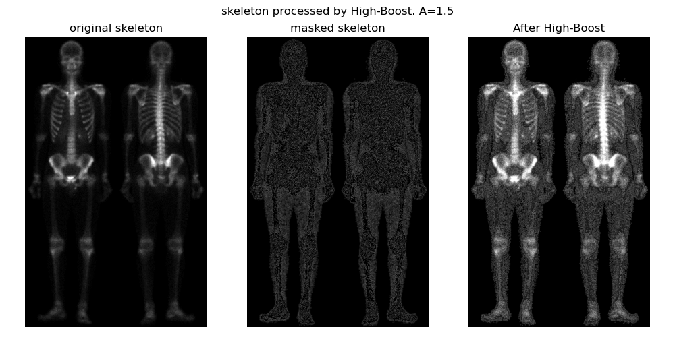

**Discussions**

* ***The impact of the different filtered masks on same image***

針對每張圖有做簡單的分析，對進行數值上的分類：



* filtered mask =

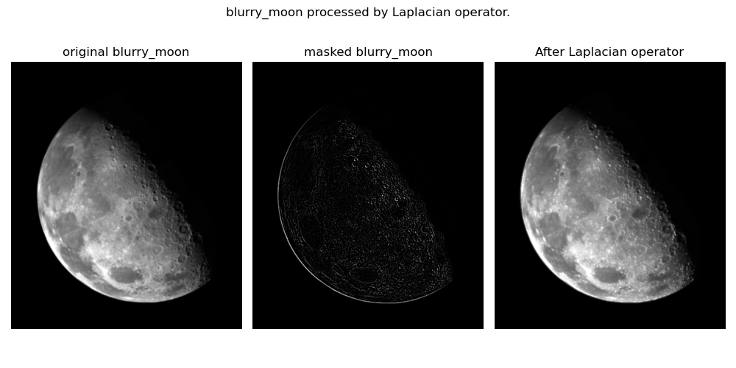

white: 0

medium: 207138

black: 42494

* filtered mask =

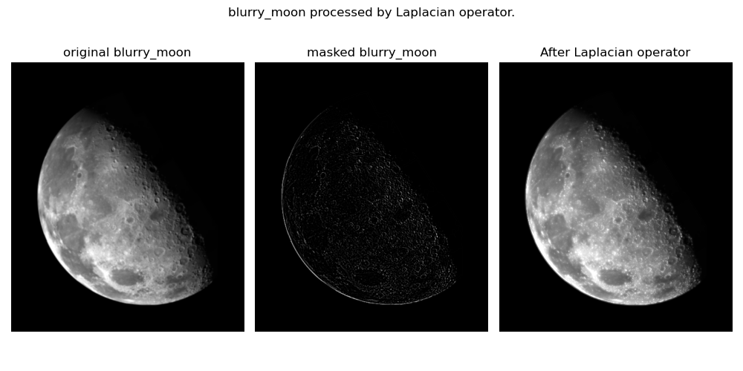

white: 3

medium: 200207

black: 49425

* filtered mask =

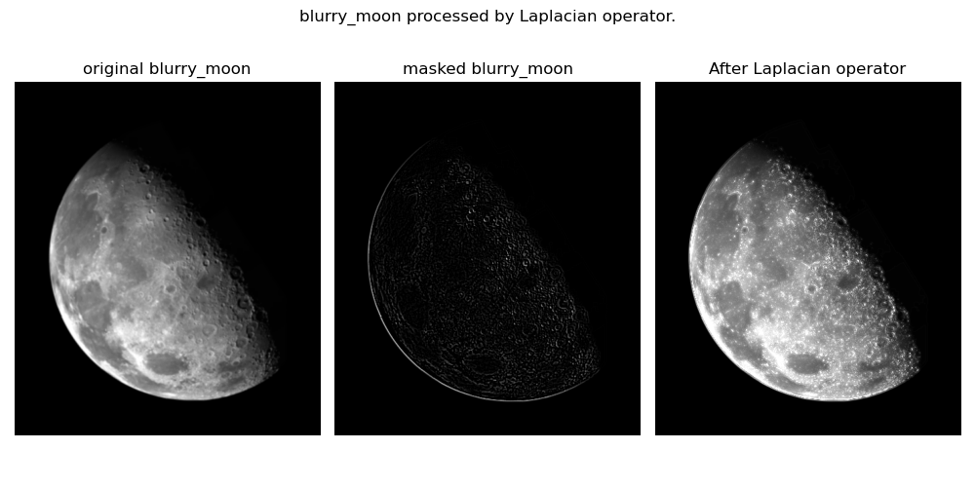

white: 0

medium: 204913

black: 44729

* filtered mask =

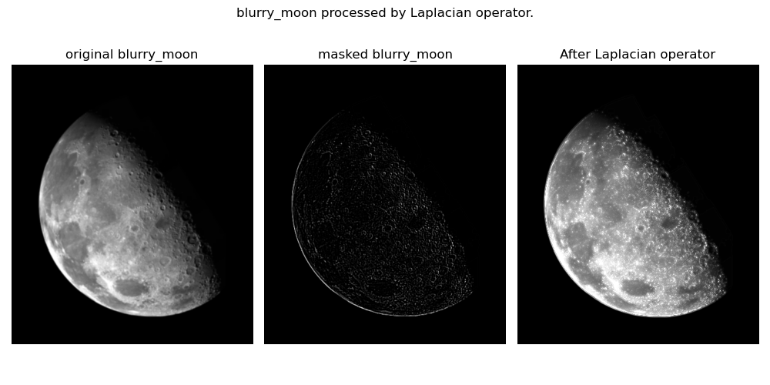

white: 0

medium: 197479

black: 52150

雖然光看圖片並不能完全分辨之間的差別，但可以明顯看出來the center coefficient of Laplacian filter(k) +/-8與+/-4的差別，+/-8最後的enhancement image有較多的細節。

從簡單的數值cluster可以看出在+/-8的masked image，gray-level在medium level有較多的數量，而+/-4的masked image，gray-level在black有較多的數量。可以推測，k=+/-8針對細節做更多的加強，而k=+/-4針對邊緣(edge)會做更多加強。

在正負值的差別，以k=8與k=-8為例，k=8的medium/black差值(197479 - 52150)為145,329，k=-8的差值(204913 - 44729)為160,184，k=-8具較多集中在medium level，因此推測負值對細節較敏感，且其差值較大，且觀察下表，|k|越大其正負值之medium-black會有更明顯的差值，有更強烈的enhancement effect。

|  |  |  |  |
| --- | --- | --- | --- |
| k | medium | black | medium-black |
| 4 | 200207 | 49425 | 150,782 |
| -4 | 207138 | 42494 | 164,644 |
| 8 | 197479 | 52150 | 145,329 |
| -8 | 204913 | 44719 | 160,194 |

* ***The impact of the constant “A” in the High-Boost process***

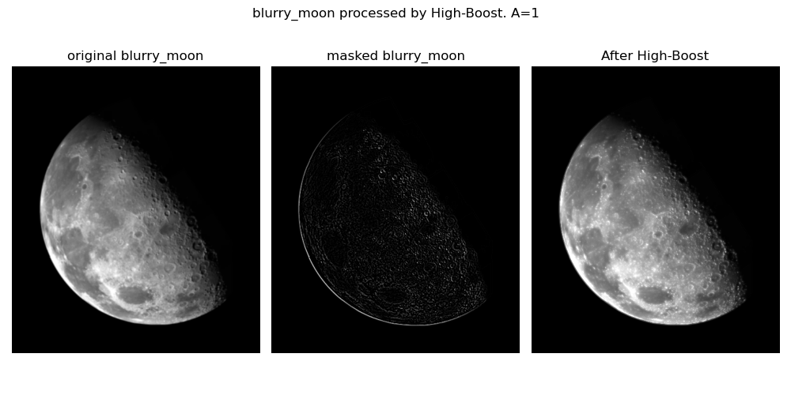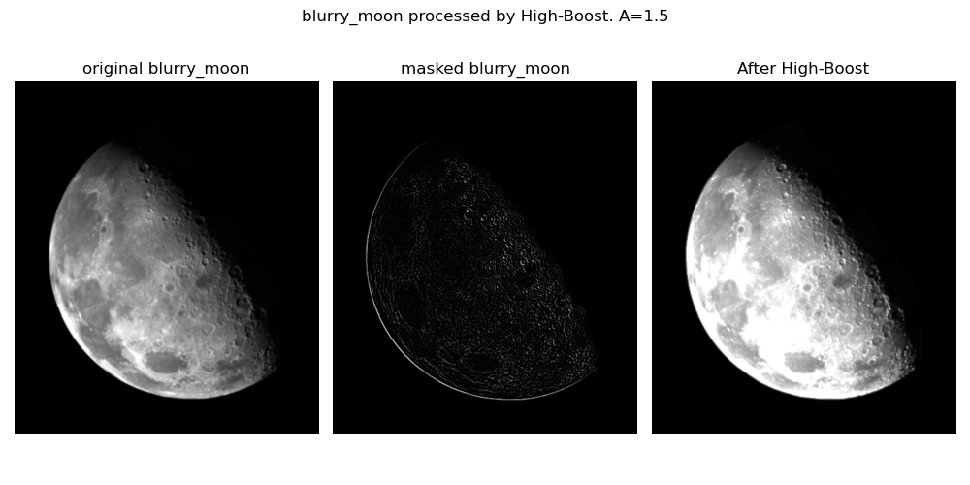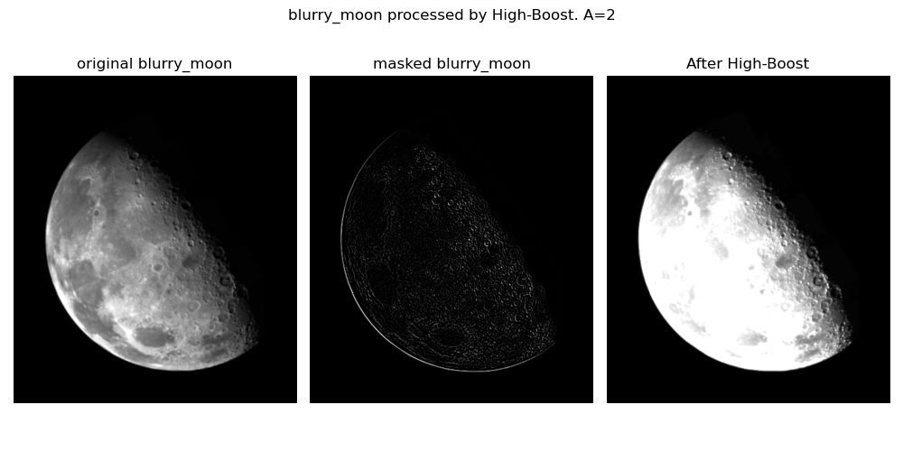

The enhancement image with constant A=1, 1.5, 2, respectively.

由上圖可以發現，當constant A越大，，原圖的gray-level分布會更趨近於255，灰階與亮部會變得更白，因此可以很明顯地看到enhancement image隨著A變大，整體高光所佔比例會越來越大。

**References and Appendix**

[Matplotlib documentation — Matplotlib 3.8.4 documentation](https://matplotlib.org/stable/)

[Matplotlib Subplot (w3schools.com)](https://www.w3schools.com/python/matplotlib_subplot.asp)

[NumPy documentation — NumPy v1.26 Manual](https://numpy.org/doc/stable/)

https://ecourse2.ccu.edu.tw/mod/resource/view.php?id=857335